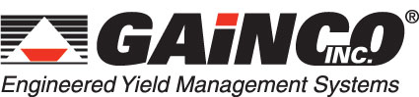

For more information contact:
Jim Petersen
Director of Marketing & Business Development
(770) 534-0703
jpetersen@gainco.com

. . . For immediate release . . .

GAINCO INTRODUCES
QISS™ QUALITY INSPECTION SYSTEMS
FOR POULTRY PROCESSING

Atlanta, Ga., January 28, 2009 — New labor-saving QISS™ quality inspection systems from Gainco, Inc. improve inspection data accuracy and reduce redundant data entry steps. QISS™ quality inspection systems provide a paperless means for gathering inspection data of incoming, outgoing or work-in-process (W-I-P) product stored in combos or pallets of totes and boxes. The systems deliver significant improvements in speed and accuracy to the all-important quality inspection function at poultry processing facilities – while at the same time reducing the labor resources required for the process.

QISS™ quality inspection systems successfully introduce greater speed, simplicity and accountability into the quality process and procedures. Operators enter data in real-time via a touchscreen that features graphical icons and multilingual capabilities. Multiple modes are available, including 100% inspection or random inspection. Moreover, operators can be measured on every defect they record and when it occurs, ensuring that timely, objective quality checks are happening. All data is available in spreadsheet format for timely feedback to internal or external suppliers or customers.

A major attraction of QISS™ quality inspection systems is that they are customizable for the needs of any individual poultry processing plant. Systems can be configured to gather data such as kill date, arrival date and time, Julian code date, the supplier of raw product, bill of lading (including truck/trailer number), product temperature, piece count, defect incidence, as well as the label weight, actual weight, and calculated over- or under-weights (by box, tote or combo).

This advanced, automated data collection and reporting reduces the potential for human error and also improves productivity over manual reporting. Equally important, plant supervisors stay abreast of quality information in real time, “as it happens.”

Each QISS™ quality inspection system from Gainco is engineered to operate flawlessly in the harsh environment of poultry processing. The system’s heavy-duty construction stands up to fluctuating hot/cold temperatures, humidity and daily high-pressure chemical washdowns. All electronics and other key components are environmentally protected to increase parts longevity and reduce the need for maintenance. Moreover, the equipment’s innovative frame design leaves no place for food debris and bacteria to hide or for water to collect, resulting in better sanitation.

Another key operating feature of the QISS™ quality inspection system is the DataMan® Data Collection System, a combined software/hardware solution that allows for the integration of all remote units on the production floor. Operators can set parameters, monitor yields and throughput, and create customized reports – all from a single location. Raw data can be made available throughout the plant network as well as across the corporate network. The data can also be moved to popular databases such as Oracle, SQL Server, and DB2.

The QISS™ quality inspection system from Gainco can be integrated easily and seamlessly into existing poultry processing operations. The system will be on display at Gainco Booth #936 at the International Poultry Expo in Atlanta, GA on January 28-30, 2009. For more information on the equipment, you may also contact Jim Petersen at (770) 534-0703 or e-mail your request to info@gainco.com.

Since 1984, Gainco, Inc. has been a leader in the development of online electronic weighing, sizing, sorting and distribution systems that increase yields, productivity and efficiencies in meat and poultry processing plants. Gainco manufactures a full range of bench and floor scale equipment as well as automated weighing systems and equipment. The company’s extensive product line includes in-motion portion sizing equipment, high-speed sorting and counting systems for poultry applications, plus batch weighing equipment for processing parts into bags and/or boxes. It also provides comprehensive equipment service, repair and spare parts support through its Blue Ribbon Service subsidiary.

Gainco systems and equipment are installed in the facilities of major meat and poultry processing companies inside and outside the U.S. The company is a subsidiary of Bettcher Industries, Inc. Web site address: www.gainco.com.

###
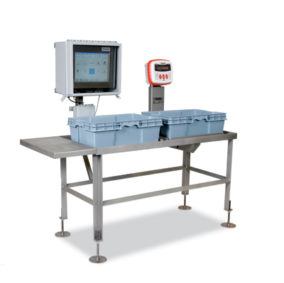

File name: GaincoQuiss.jpg
Photo Caption:
QISS™ quality inspection systems from Gainco, Inc. improve inspection data accuracy and reduce redundant data entry steps.

